ריצתפלחהספוט
םיריצהתכשל:אל
____________________ןוגרא/תעיסחוכבא
_____________________:תמא
___________________________________:תאריצכרשאלםישקבמואנ
___________________:םירוגמץאר
_________:ןוכדר/.זת.
תעדהוהזבףרוצמ.רטפתהש________________________:םוקמב
.המוחתתורטפתה
סרגנוקהדרשמלחולשלוהמיתחםעקורסקתועףרצליש
Brachac@wzo.org.il
DATE:_______________:ךיראת
TIME:_________:העש
SIGNATURE:_____________________________:המיתח
-ע"צהלשתויטרפהתוינידמלםאתהבהשעייעדימבשומיהש
http://www.wzo.org.il/privacy
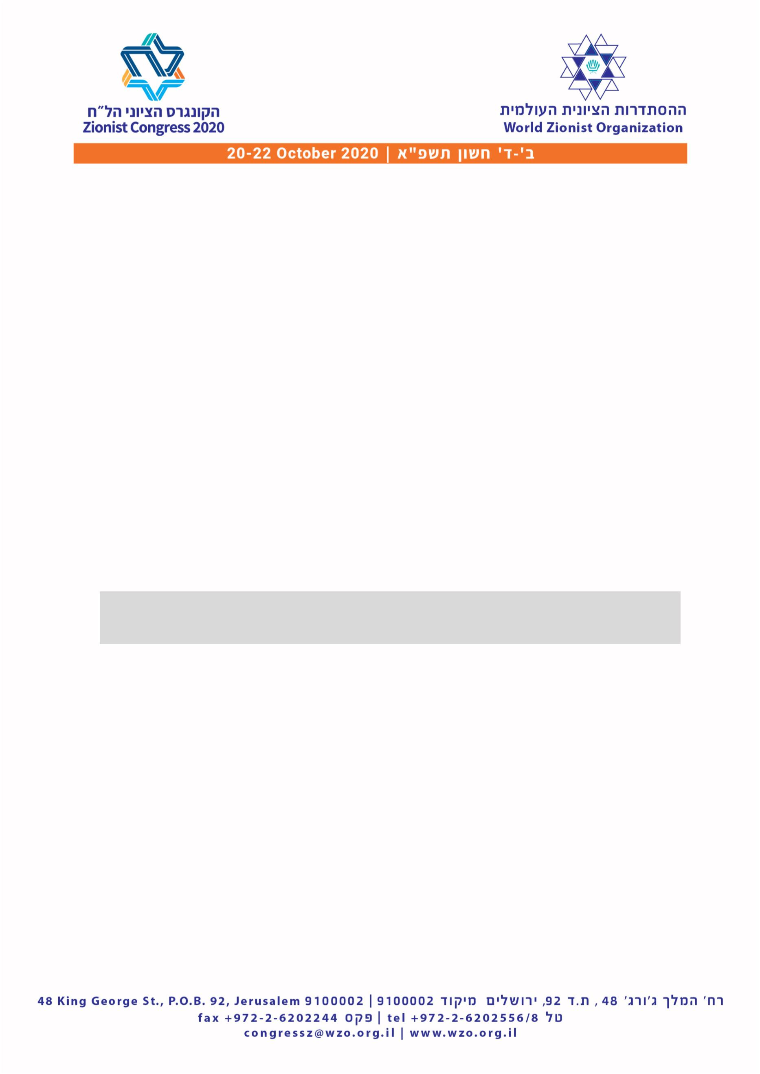

Delegate Replacement Form
To: The Office of Delegates
From: _____________________
Legally representing faction / organization
_
_
_
We ask to confirm as delegate: ___________________________________
ID. / Passport: __________________ Country of residence: _________________
Instead of: ________________________ who resigned. Attached is a signed
resignation notice.
The signed and scanned form must be attached, and sent to the
Congress Office at Brachac@wzo.org.il
The information will be used in accordance with the WZO’s privacy policy -
http://www.wzo.org.il/privacy
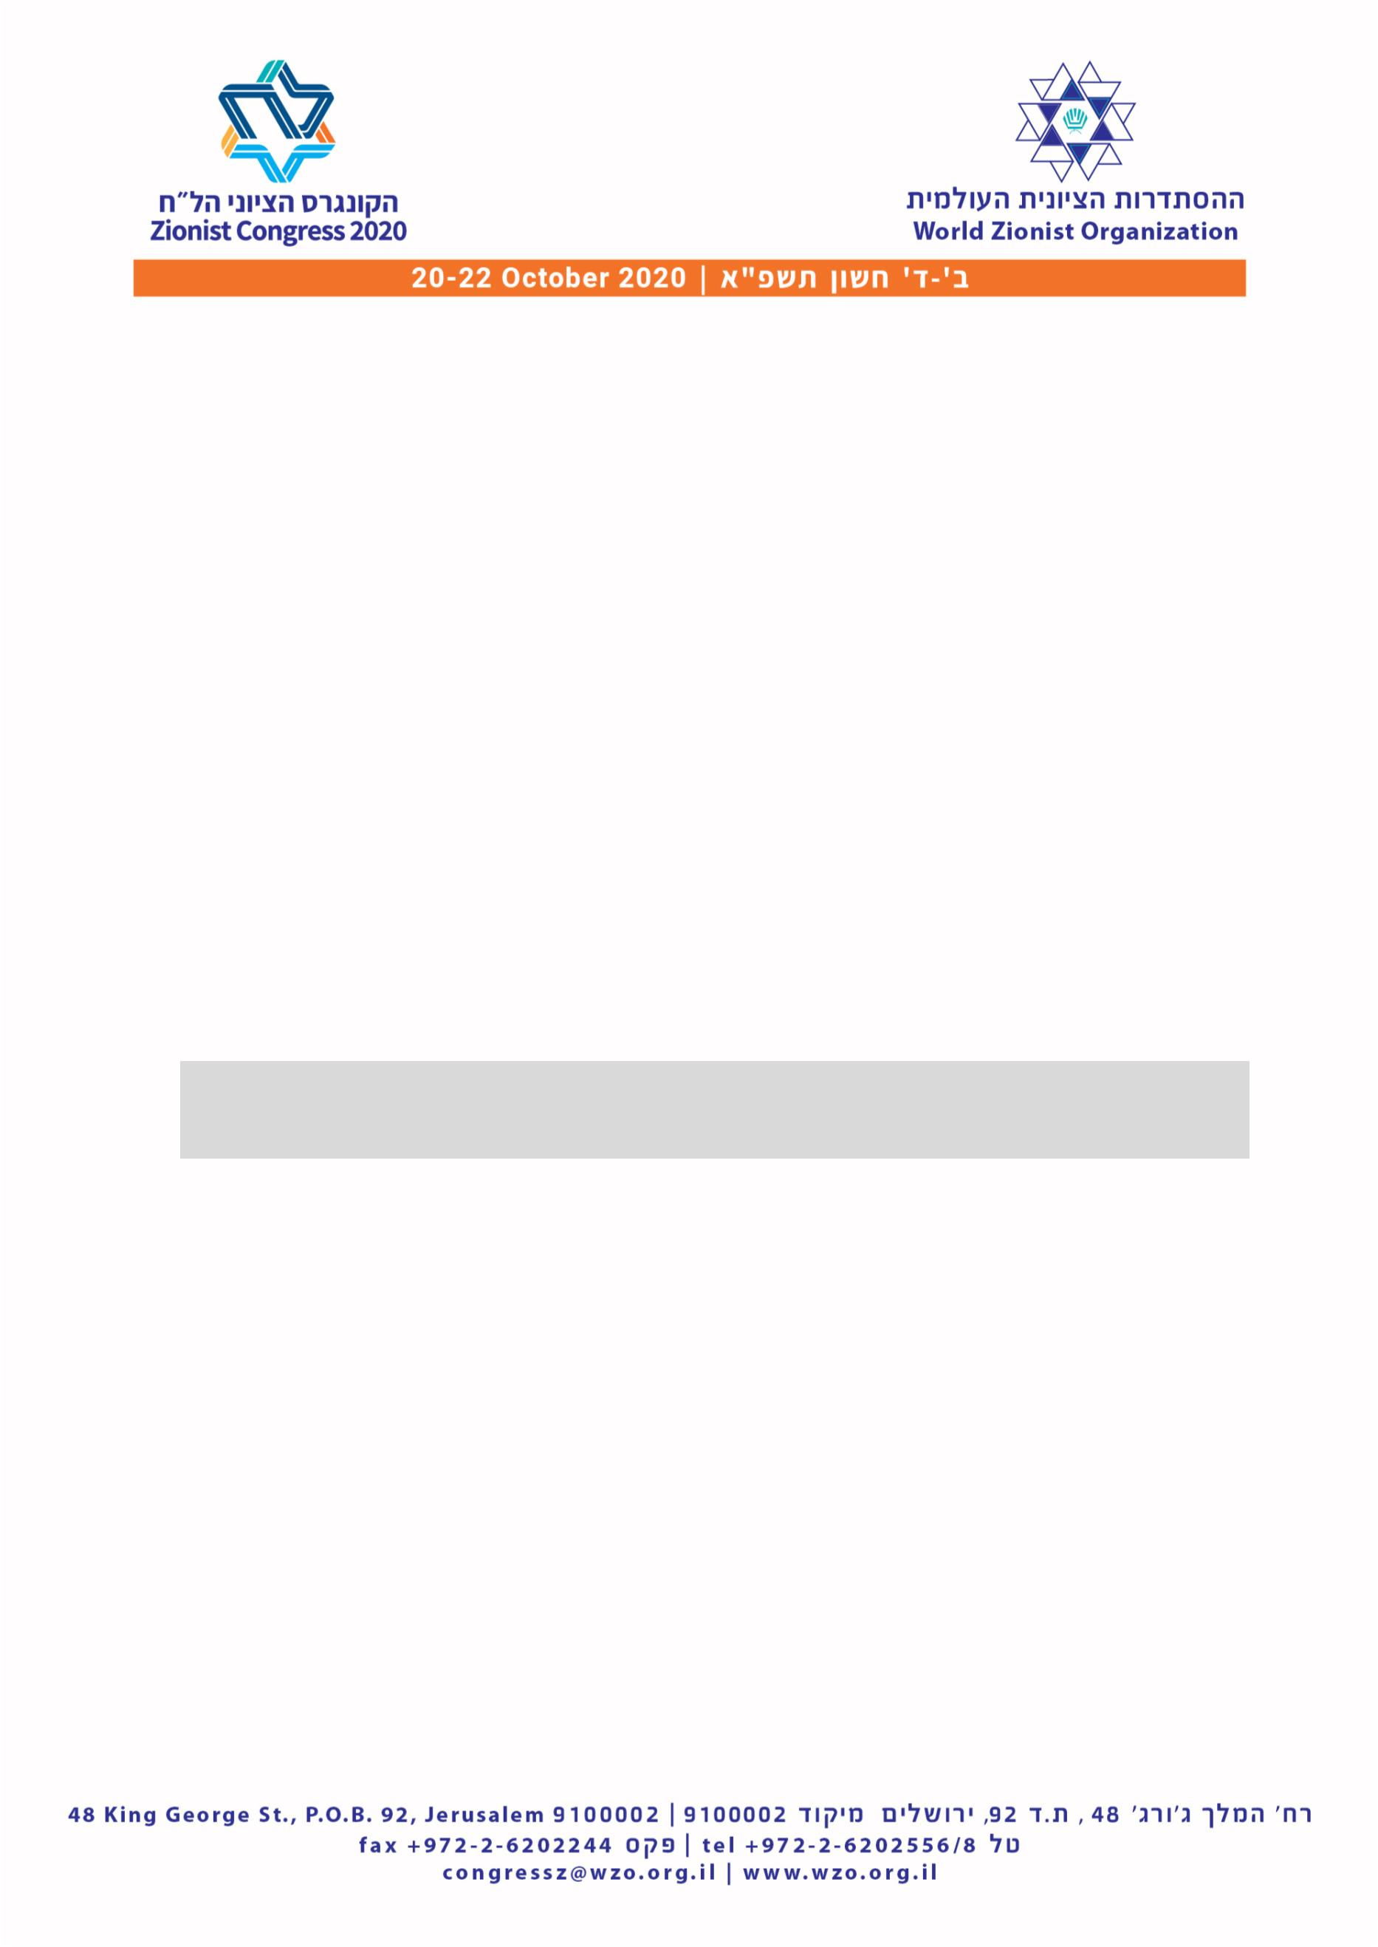

Only two pages were converted.
Please Sign Up to convert the full document.
www.freepdfconvert.com/membership

